Blaise Johnson

Assignment 1

Repository Screenshot

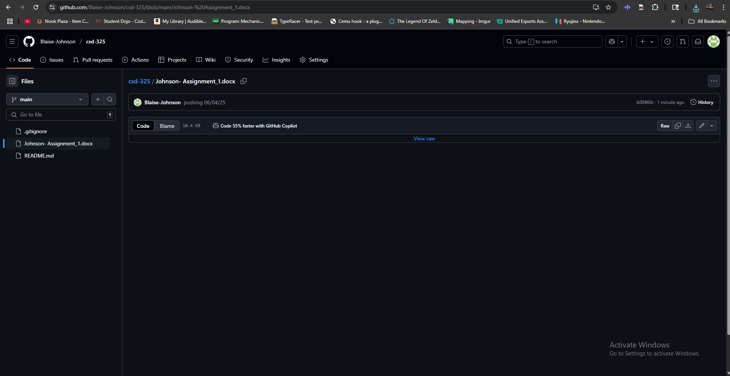

Repository URL

<https://github.com/Blaise-Johnson/csd-325/blob/main/Johnson-%20Assignment_1.docx>

Local Directory

